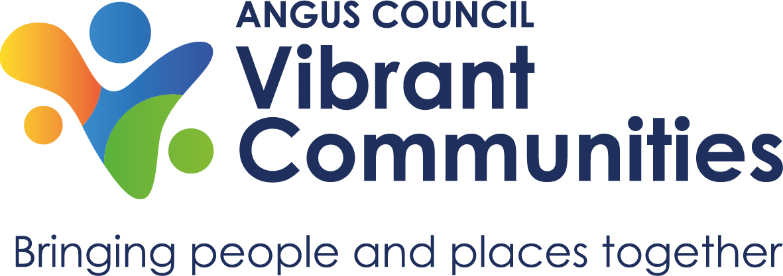

**Community Council/Community Group**

**Engagement Plan Template**

This template has been designed to assist community councils and community groups to build an effective engagement plan that will empower communities to have a collective voice and enhance local decision-making.

# **How Community Councils could/should consult with their Communities**

* Community Councils are the most local tier of statutory representation in Scotland. Community Councils have a responsibility to communicate with all the residents living in your community. This should be undertaken regularly and effectively to be able to claim that the

Community Council represents the community’s views and needs, and not the personal opinions of Community Councillors.

* Community Councils, by law, must be non-discriminatory. They should be welcoming, open and non-judgmental toward all citizens, including youths and individuals from underrepresented or minority groups. Nobody should be blocked from Community Council activities.
* When establishing views, Community Councillors should canvass local opinion but be careful not to be perceived as orchestrating campaigns unless endorsed by the Community. Community Councils should be aware that it is often only a vocal minority who make representations. The Community Council should seek to represent the views of the whole Community.
* Engagement can range from providing information about current work or projects, to consulting on particular issues, to full empowerment whereby the community has decision-making powers.

* Some of the engagement needs to be ongoing and some of it might be short-term or one-off events.
* There is not one correct way for a Community Council to engage with its citizens and what works for one part of the community might not reach other members of the local area.

The information above is specific to community councils, however the principles can be followed by any community group, whether of place or of interest, to gain a better insight into the needs, challenges, and aspirations in their communities.

**National Standards for Community Engagement** sets out good practice principles designed to support and inform the process of effective community engagement. There are seven elements for community engagement:

1. 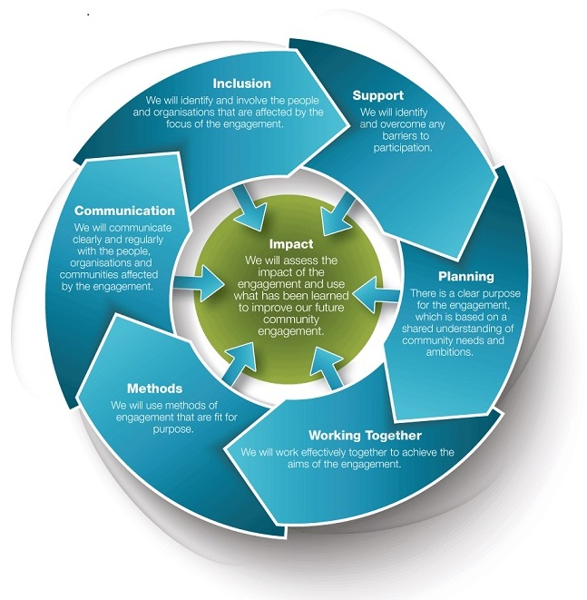**Inclusion**
2. **Support**
3. **Planning**
4. **Working together**
5. **Methods**
6. **Communication**
7. **Impact**

|  |  |  |  |  |  |
| --- | --- | --- | --- | --- | --- |
| **DETAILS** | **TARGET GROUPS/INDIVIDUALS** | **HOW** | **WHAT TO SHARE** | **WHO** | **TIMESCALE** |
| **Inclusion**  Identify and involve the people and organisations that are affected by the focus of the engagement | All residents of CC area | Notice boards/social media/connecting with other groups in area/village or community halls/uniformed groups | Minutes; Agendas; Upcoming events etc. |  |  |
| Protected Characteristics |  | | | |
| Age (old & young) | Sheltered complex/Churches/ other places of worship/Social media/ school newsletter/parent council/post office/shops/GP surgeries/early years learning groups etc. |  |  |  |
| Race | ESOL groups/D&A College/Resettlement Team/International Shops/Local farmers etc. |  | Contact Angus Council Vibrant Communities Team |  |
| Gender Reassignment/ Sexual Orientation/ Pregnancy/Maternity/  Marriage/Civil Partnership | Angus Health and Social Care Partnership/GP Surgeries/ Health Visitors/Voluntary Action Angus (VAA) |  |  |  |
| Disability | Angus Disability Forum/Disability Information Scotland (0300 323 9961)/ Community Link Workers (VAA) |  |  |  |
| Faith groups | Temples/Churches/Mosques/Synagogues/ Interfaith spaces/Local Meeting Houses/Kingdom Halls |  |  |  |
| **DETAILS** | **TARGET GROUPS/INDIVIDUALS** | **BARRIERS** | **SUPPORT** | **WHO** | **TIMESCALE** |
| **Support**  Identify and overcome barriers to participation | Examples of groups that you may want to consider:   * Disability Groups * Youth Groups * Recovery Groups * Minority Ethnic Community Groups * Young families * Single parents * Older people * LGBTQ+ * Faith groups   Any member of the community may have to overcome barriers to participation depending on their circumstances, not just those groups mentioned above. | Examples of support need:   * Travel/out-of-pocket expenses * Digital exclusion * Access to information * Caring for dependants (for example, childcare or care of older people) * Inflexibility of working hours * Personal assistance or personal care/ Meetings and events organised at appropriate times * Suitable and accessible venues and appropriate catering * Access to interpreters * Communication aids | * Combined in-person/on-line meetings * Arrange meetings in different locations * Help with get the access to wifi or digital devices * Help with basic digital skills * Share information far and wide with all appropriate contacts in both digital and physical formats. * Publicise on local radio station e.g. Radio North Angus * Arrange creche or caring provision (where possible) * Schedule meetings to out of office hours * Avoid arranging early morning or late evening meetings * All venues should be accessible for all members of the public. * [Angus Council Interpretation and translation](https://www.angus.gov.uk/contact_the_council#:~:text=Our%20contact%20centre%2003452%20777,before%2010am%3A%20Wednesday)   service 03452 777 778/   * Contact local ESOL tutor (English for Speakers of Other Languages) for advice/guidance * For those who are visually impaired ensure minutes/notes are available in accessible format and size. * For those with a hearing impairment ensure a hearing loop is used during each meeting. * Consider sign language interpreter where possible. * Ensure physical copies of agendas, minutes, notes etc are available in the local community e.g. mobile library/noticeboards/GP surgeries/Post Office etc. * Sight Scotland <https://sightscotland.org.uk/> * RNID [RNID in Scotland - RNID](https://rnid.org.uk/about-us/rnid-in-scotland/) |  |  |

|  |  |  |  |  |  |
| --- | --- | --- | --- | --- | --- |
| **DETAILS** | **TARGET GROUPS/INDIVIDUALS** | **HOW** | **WHO** | **TIMESCALE** |  |
| **Planning**  There is a clear purpose for the engagement, which is based on a shared understanding of community needs and ambitions. | Depending on the nature of the projects, identify your stakeholders.  For example,   * if you are looking to develop a Local Place Plan, all sections of the communities should be involved and therefore the stakeholders. * If you are trying to establish a new Skate Park, your main stakeholders may be young people, parents, carers, schools, Sports Hub Co-ordinator etc.. | * Bring your stakeholders on board at the beginning of the process to define the focus of your project. * set out what you want to achieve * agree the timescale * agree what evidence you need to take your project forward * agree what success would look like * agree what resources you will need to ensure success * All available information has been shared to develop the engagement plan. * agree an engagement plan that will meet your needs e.g. using the [VOiCE](https://www.scdc.org.uk/what/voice)tool |  |  |  |
| **DETAILS** | **TARGET GROUPS/INDIVIDUALS** | **PROJECT TEAM** | **PARTICIPANTS** | **WHO** | **TIMESCALE** |
| **Working together**  Work effectively together to achieve the aims of the engagement | Project team | Across the team, the following are clear at all times:   * Roles and responsibilities of all involved * Decision-making process * Methods of communication * Ground rules * Communication between all participants is open, honest and clear * The community engagement process is based on trust and mutual respect * Participants are supported to develop their skills and confidence during the engagement | * Communication between all participants is open, honest and clear * The community   engagement process is based on trust and mutual respect   * Participants are supported to develop their skills and confidence during the   engagement |  |  |

|  |  |  |  |  |  |
| --- | --- | --- | --- | --- | --- |
| **DETAILS** | **TARGET GROUPS/INDIVIDUALS** | **How** | **WHO** | **TIMESCALE** |  |
| **Methods**  Use methods of engagement that are fit for purpose | As noted in the section of Inclusion and Support | * focus groups * public meetings * pop-up events * chat with people at existing events * community action research * online survey * social media campaigns * etc. |  |  |  |

|  |  |  |  |  |  |
| --- | --- | --- | --- | --- | --- |
| **DETAILS** | **TARGET GROUPS/INDIVIDUALS** | **How** | **WHO** | **TIMESCALE** |  |
| **Communication**  Communicate clearly and regularly | Same as noted in the section of inclusion and support | * Information on the process and results of the engagement is clear and easy to access and understand. * Ensure all participants and the wider community are aware of the result of the engagement via the same process as in the section of Inclusion and Support * Bear in mind confidentiality (GDPR) when sharing information. * System is in place for ongoing two-way communication with communities e.g. suggestion box, email contact, Facebook messenger etc. |  |  |  |

|  |  |  |  |  |  |
| --- | --- | --- | --- | --- | --- |
| **Details** | **Who** | **What** |  |  |  |
| **Impact**  Assess the impact of the engagement and use what we have learned to improve our future community engagement | Project Team  Wider group | * Did we achieve what we set out to do? * Did we reflect the views of all sections of our community? * Did we base our decisions on those views? * Did we share the results of the engagement with the community? * Did we inform our community of what decision we intend to take forward? * Did we provide continuous feedback to our community? * What did we learn that would help improve future engagement? * Shout out the impact! |  |  |  |

**Acknowledgement**

**We would like to thank Muirhead, Birkhill & Liff Community Council for their input in this template.**

**Useful links**

Community Councils Scotland :[Community Council (communitycouncils.scot)](https://www.communitycouncils.scot/)

National Standards for COmmunity Engagement VOiCE: <https://www.voicescotland.org.uk/voice/>

# **Training**

Online training resources available:

* The SCDC delivered a [webinar for community councillors](https://www.communitycouncils.scot/help-and-support/engagement)on the National Standards for Community Engagement which can be viewed below:
* TURAS Learning: <https://turasdashboard.nes.nhs.scot/>

This course is an introduction to community engagement and will show you the benefits of good community engagement as well as some methods of engagement.

* [Open university Skills and Learning for CCs](https://www.communitycouncils.scot/help-and-support/skills-and-learning)

Digital skills-Google, MS

Business skills – project, public leadership

Fundraising

Community and society – legal skills, law making